

The IEEE Ottawa Section, IEEE Ottawa Joint Chapter of Communications Society, Consumer Electronics Society, and Broadcast Technology Society (ComSoc/CESoc/BTS), IEEE Ottawa Joint Chapter of Reliability Society and Power Electronics Society (RS/PELS), IEEE Ottawa Educational Activities (EA), and Algonquin College Student Branch (ACSB) in conjunction with School of Advanced Technology, Algonquin College are inviting all interested IEEE members and other engineers, technologists, and students to a seminar

IEEE Standards Development Ecosystem
and ComSoc Standards and Standards-related Activities
By
Dr. Alexander D. Gelman,
Director - Standardization Programs DevelopmentIEEE Communications Society

DATE: Tuesday, April 5, 2016.
TIME: Refreshments, Registration and Networking: 18:00; Seminar: 18:30 – 19:30
PLACE: Algonquin College, T-Building, Ciena Optophotonics Lab (Room T129), 1385 Woodroffe Ave., Ottawa, Ontario, Canada
PARKING: No fee after 5 p.m. at the Parking Lots 8 & 9. Please respect restricted areas.
ADMISSION: Free. Registration required. To ensure a seat, please register by e-mail contacting:
almuhtadi@ieee.org.
MORE INFO: Ottawa ComSoc/CESoc/BTS Chapter website.

Abstract – In this presentation the IEEE and ComSoc Standards Activities are positioned and explained as a part of the IEEE total value proposition and the IEEE role in technology evolution from a concept to R&D and to standards and deployment.
IEEE Standards Activities ecosystem will be explained. We will address the role and modus operandi of IEEE Standards Association and the role of Technical Societies and Councils, Industry and Academia in the IEEE standardization activities.
It will be a tutorial of how the IEEE Standardization cuisine works and how any materially or professly interested party can participate in the standardization process.
We will highlight the unique IEEE standardization process and IEEE standards-related policies.
Sample communications and networking standardization and pre-standardization projects in such areas as PLC, Smart Grid, IoT, SDN, Big Data and 5G will be addressed. ComSoc standards–related technical activists, such as conferences and publications will be discussed..

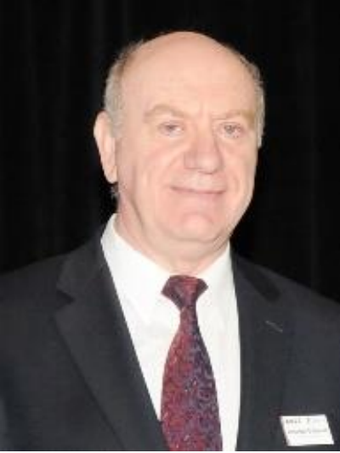
Speaker’s Bio
Alexander D. Gelman received M.E. and Ph.D. degrees in Electrical Engineering from the City University of New York. Presently he is CTO of NETovations consulting group that supports industry in competitive research and intellectual property management in areas of communications and networking.
During 1998-2007 Alex worked the Chief Scientist of the Panasonic Princeton Research Laboratory, managing research programs in consumer communications and networking; during 1984-1998 worked at Bellcore, most recently as Director-Internet Access Architectures Research.
Alex has numerous publications and several patents. He pioneered multi-point Multimedia Communications and DSL applications for managed services (IPTV). Alex holds some of the earliest system patents in VoD and DSL areas, e.g. on xDSL Internet Access Router. He managed research projects that included competitive industrial research as well as standardization in industry consortia and global standards development organizations.
Alex is a seasoned IEEE and ComSoc volunteer. He is a cofounder the IEEE conference on Consumer Communications and Networking (CCNC), helped to acquire for ComSoc the International Symposium on Power Line Communications (ISPLC), the IEEE Conference on Peer-to-Peer Computing, IEEE-SIIT and IEEEBlackSeaCom conferences; served on the inaugural Steering Committee for Transactions on Multimedia and the IEEE International Conference on Multimedia and Expo (ICME) and IEEE-CSCN; initiated a Communications Standards Supplement to the IEEE Communications Magazine as an incubation phase for IEEE Communications Standards Magazine; chaired the Technical Committee on Multimedia Communications, served four terms as ComSoc Vice President.
Alex initiated several standardization projects and initiated the ComSoc Standards Board, served as ComSoc Director of Standards. During his term ComSoc received the IEEE Standards Association Entity Standards Sponsor award.
Alex served on IEEE-SA BoG and on Standards Board and its New Standards, Standards Review, Patents and Industry Connections committees, e.g. representing TAB in 2008, 2010, and in 2012. In 2008 Alex chaired TAB’s Ad Hoc Committee on Standards.
Alex architected ComSoc Standards Activities Council and was elected the first ComSoc Vice President – Standards Activities. Alex is a recipient of MMC TC Distinguished Service award and ComSoc Donald W. McLellan Meritorious Service Award. And IEEE-SA Standards Medallion.

.

