

The IEEE Ottawa Antennas and Propagation Society and Microwave Theory & Techniques Society (AP/MTT) Joint Chapter, Electromagnetic Compatibility (EMC) Chapter, Components, Packaging and Manufacturing Technology (CPMT) Chapter, IEEE Ottawa Section (OS), and Department of Electronics (DoE) at Carleton University are inviting all interested IEEE members and other engineers, technologists, and students to the IEEE MTT-S Distinguished Lecture.

DATE: Friday, January 22, 2016.
TIME: 11:30 am – 1:00 pm.
Hospitality: Refreshments will be served.
PLACE: Carleton University, Department of Electronics (DoE), Mackenzie Engineering Building, Room ME 4124, 1125 Colonel By Drive, Ottawa, Ontario, Canada.
ADMISSION: Free. Registration required. To ensure a seat, please contact
Dr. Qingsheng Zeng (qzeng@eecs.uottawa.ca)

IEEE Distinguished Microwave Lecture
Wonderful World of Nonlinearity: Modeling and Characterization of RF and Microwave Circuits

Prof. José C. Pedro
Instituto de Telecomunicações – Universidade de Aveiro
3810-193 AVEIRO, Portugal

Abstracts
Despite the many studies that have been undertaken to understand the wonderful world of nonlinearity, most undergraduate electrical engineering programs are still confined to linear analysis and design tools. As a result, the vast majority of microwave designers still cannot profit from the significant technological advancements that have been made in nonlinear circuit simulation, active device modeling and new instrumentation for performance verification. So, they tend to conduct their designs relying on experience, empirical concepts, and many trial and error iterations in the lab.
This talk will reveal the ubiquitous presence of nonlinearity in all RF and microwave circuits and the recent efforts made to understand, model, predict, and measure its diverse manifestations. We aim to bring microwave engineers’ attention to newly available techniques, and attract researchers to pursue further studies on this scientifically exciting topic.
Starting with some elementary properties of nonlinear circuits (like nonlinear signal distortion, harmonic generation, frequency conversion and spectral regrowth), we will show that nonlinearity is present in all wireless circuits, either to perform a desired signal operation or as unintentional distortion. In this way, we will show how oscillators, modulators or mixers could not exist without nonlinearity, while power-amplifier designers struggle to get rid of its distortion effects.
After this theoretical overview, we will introduce some recent advancements in nonlinear microwave circuit analysis tools and illustrate different types of models that are currently being used to represent and predict device, circuit, and system performance. Finally, we will focus the talk on the key metrics that are used to characterize nonlinear behavior, as well as newly developed lab instruments and their ability to assess device performance.

Speaker’s Bio
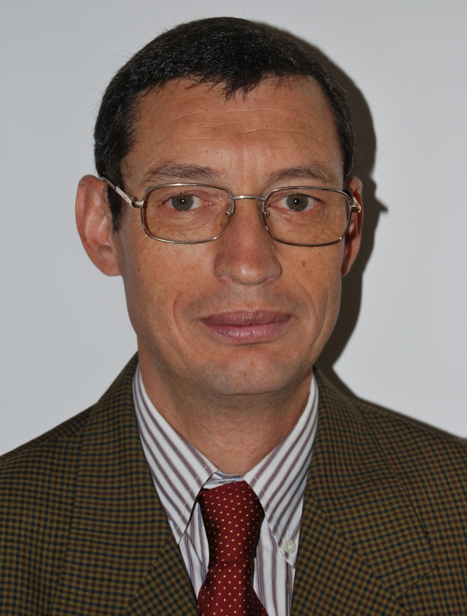

José C. Pedro received the diploma, doctoral and habilitation degrees in electronics and telecommunications engineering, from University of Aveiro, Portugal, in 1985, 1993 and 2002, respectively.
From 1985 to 1993 he was an Assistant Lecturer at University of Aveiro, and a Professor since 1993. Currently he is a Full Professor at the same University, and a Senior Research Scientist at the Institute of Telecommunications.
His main scientific interests include active device modeling and the analysis and design of various nonlinear microwave circuits, in particular, the design of highly linear multi-carrier power amplifiers and mixers. He is the leading author of Intermodulation Distortion in Microwave and Wireless Circuits (Artech House, 2003), has authored or co-authored more than 200 papers in international journals and symposia, and served the IEEE in the Portuguese MTT/AP/ED Joint Chapter, the MTT-11 Technical Committee and as a reviewer and Associate Editor for the MTT Transactions and reviewer for the MTT-IMS and the EuMC.
Prof. Pedro has served his university department as the Coordinator of the Scientific Council and as the Department Head.
Prof. Pedro received the Marconi Young Scientist Award in 1993 and the 2000 Institution of Electrical Engineers (IEE) Measurement Prize. In 2007 he was elected Fellow of the IEEE for his contributions to the nonlinear distortion analysis of microwave devices and circuits. Currently, he is an IEEE MTT-S Distinguished Microwave Lecturer.

